**Social Media Automation Tools**



**What is social media automation?**



Social media automation is the process of using tools or software to manage repetitive tasks on social media platforms, like posting content or producing reports, without manual labour.

Tools that automate post-scheduling, basic customer service, and analytics reports can save social media managers valuable time for higher-priority tasks.

What can you automate in social media marketing?

You can automate many (but not all!) tedious social media marketing tasks. And don’t worry—we’ll get to the software tools that can take care of these tasks for you at the bottom of this post.

Let’s face it: we can’t *always*be the Vincent Van Gogh-sequel creative geniuses we often are. Sometimes, we’re more like Vincent Van No. But, if you need a hand brainstorming content idea, you can always turn to a generative AI tool to help you out.

Look, you can (and should) automate text-based content, visuals, and videos using generative AI. But you absolutely need to review and edit AI-generated results. AI isn’t perfect (none of us are), but it’ll give you that get-up-and-Gogh boost you need.

**Social scheduling and publishing**

Switching between different social accounts to publish multiple times per day can take up a lot of time. Especially because the best time to post and content best practices vary by platform.

Automatic social media posting saves time and increases efficiency without reducing content quality. Once your content is locked and loaded, you can use automated social media posting to schedule the appropriate pieces and post times on each network. Then sit back, relax, and let the robots take your posts over the finish line.

**Basic customer service**

The 2023 social trends report saw a massive dip in online customer satisfaction rates. But why are people so unhappy? Once the world officially reopened (bye-bye COVID), business owners stopped paying attention to online customer service.

So, what does this mean for your business?

There’s a gaping hole in the ecommerce market, one you can fill with better customer service. And one way to do that is to use customer interaction automation.

You don’t need a human team member to answer common questions like “What are your hours?” and “Do you have any coupons available?” Likewise, you can automate service requests related to package tracking, refund status, and other issues tied to your CRM.

Conversational AI tools can handle more basic work without drastically affecting your business’s bottom line.

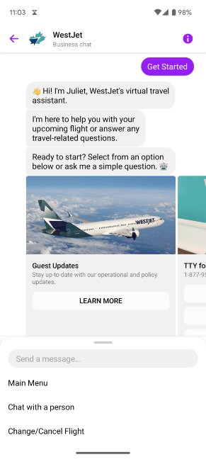

**Data collecting**

Automated data collection makes analytical reporting and decision-making a *lot*easier. Luckily, social media marketing automation was practically built to take care of the tedious number crunching you truly hate.

Automated data collection can include things like:

* Platform-specific social data, like the best time to post on Instagram vs. TikTok
* Post engagement stats, like likes, comments, shares, and more
* Keyword or hashtag tracking, which allows you to see exactly what people are saying about your brand, themes related to your industry, and your competitors

If you find the right tool, you can even automate your reporting, generating client-ready dashboards and reports with just a few clicks.

[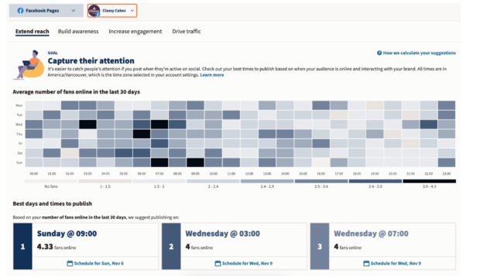](https://blog.hootsuite.com/wp-content/uploads/2024/01/Social-Media-Automation-copy.png)

Common mistakes when automating social media marketing

DON’T put all of your faith in your tools

A poor builder blames his hammer when the house falls down. When you publish a “Don’t worry, be happy” post the same day as a global tragedy, the same goes for you.

tl;dr? Don’t set it and forget it unless you want your house to topple. Automating social media marketing doesn’t mean you flip a switch and walk away.

It’s important to monitor any automated outputs, including your publishing schedule. That way, you can make any adjustments required in real time.

World-changing crises happen all the time on social media. A poorly timed post can make your brand look out of touch or tactless.

**DON’T use spammy bots**

Just because some tools exist doesn’t mean you should use them. Remember: use bots for good, not evil. Embrace bots that help improve customers’ lives and your own.

AI tools that speed up customer service response times? Great. An inbox to manage DMs, comments, and tags from multiple networks in one place? Excellent.

But bots that automatically comment on or like social posts? Not such a good idea. They can cause lasting damage to your relationships with your audience. They can also land you in hot water with the social networks themselves.

**DON’T cross-post without customizing**

Cross-posting the same content to multiple social media accounts might seem like the easiest option. But it’s certainly not the most effective.

Some tools (including social media platforms) allow you to automatically cross-post to other platforms. Don’t be tempted.

Social platforms have different image display ratios, character count limits, and social features. Audiences on those platforms have different expectations, demographics, and word preferences. It’s *highly* unlikely that your link-heavy Facebook post, for example, will perform as well on linkless Instagram.

Instead, take the time to adjust your message for each platform’s audience. At the bare minimum, you’ll want to review:

* User handles, which can vary between platforms
* Image specs, like file type, size, cropping, etc.
* Text, including platform character count and platform-specific language
* Hashtags, including number and usage

Instead of cross-posting, use automated social media publishing at set times to use your time most efficiently.

**Top Social Media Automation Tools**

**1. Hootsuite**

Number one on our list is Hootsuite (*what, are you surprised?*). Hootsuite provides a comprehensive social media management platform that offers a wide range of automation features. We’ve got so many features, in fact, that we broke them out one by one below.

Hootsuite streamlines your social media marketing efforts, making it easier for you to manage all of your social accounts from one place. In our humble opinion, it’s the best social media automation tool.

This tool is best for: Medium-to-large teams, social media marketers, and content creators.

Here’s a breakdown of Hootsuite’s key automation tools and why you should care about them.

**OwlyWriter AI**

OwlyWriter AI is Hootsuite’s AI-driven, social-media-specific content-generating tool. Use it to save major time generating and testing social media captions.

[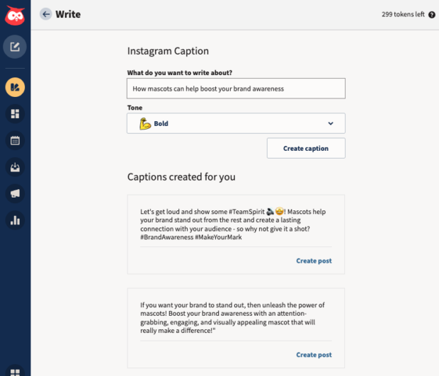](https://blog.hootsuite.com/wp-content/uploads/2024/01/Social-Media-Automation-11.png)

Key features:

* Rapid content generation. Create engaging and relevant social media posts in seconds, saving you time and creative energy.
* Instant insights. Automatically identify and repurpose your top-performing posts—*without*manually reviewing your past content.

Best Time to Publish

Timing is crucial; you want to post when your audience is happily browsing. Hootsuite’s Best Time to Publish feature analyzes, optimizes, and automates your posting schedule.

[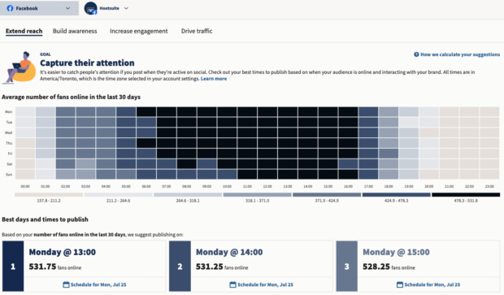](https://blog.hootsuite.com/wp-content/uploads/2024/01/Social-Media-Automation-10.png)

Key features:

* Data analysis. Analyzes your audience’s online behavior to determine the ideal times for posting.
* Improved visibility. Automatically schedule content for maximum reach and engagement. Increases the chances of your content being seen by your target audience.

**Analytics**

Most social platforms offer native analytics tools. But it can be a huge drain on your time to analyze each platform separately and compile manual reports.

Analytics makes this process *a lot* simpler. Create custom boards that show you an at-a-glance view of the metrics you want to track. Then, use automated reporting to export and send data to clients, managers, or yourself without lifting a finger.

Once you’ve set up your reports, you can measure your content performance as often as you like. You’ll get real-time updates and high-level overviews for quarterly or annual reviews.

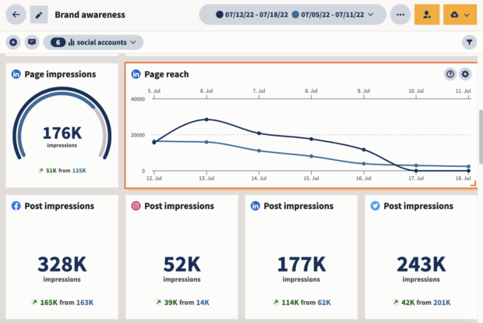

Key features:

* Customization. Generate reports tailored to your specific goals and metrics.
* Scheduled delivery. Set up automated report delivery to your inbox or team members.
* Data visualization. Presents data in easy-to-understand charts and graphs for quick insights.

**Social Advertising**

Social Advertising allows you to test hundreds of Facebook and Instagram ads and automatically reallocate your budget to the best-performing ones. It ensures you’re targeting the right audiences with the right metrics for maximum ROI.

You can automatically boost your budget or even start a new campaign based on pre-set triggers. This tool will even provide daily automatic ad performance recommendations.

Social Advertising also syncs your CRM or email list to your Facebook ad account, so you always have up-to-date custom audiences.

[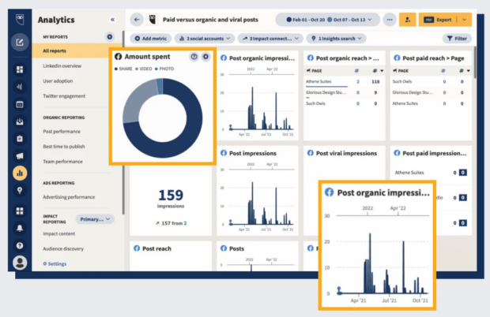](https://blog.hootsuite.com/wp-content/uploads/2024/01/Social-Media-Automation-8.png)

Key features:

* Campaign management. Create, launch, and manage social ad campaigns from one platform.
* Targeting options. Reach your ideal audience through advanced targeting capabilities.
* Budget control. Set and monitor ad budgets to optimize your ROI.

Inbox

Inbox allows you to manage conversations and mentions across all of your social platforms from one dashboard. You can also use the Saved Replies feature to address common interactions automatically.

Key features:

* Unified inbox. View and respond to messages from multiple social media platforms in one place.
* Workflow management. Assign tasks to team members and streamline your response process.
* Real-time engagement. Enhance customer service by quickly addressing queries and feedback.
* Customer feedback. Automatically trigger customer satisfaction surveys.

[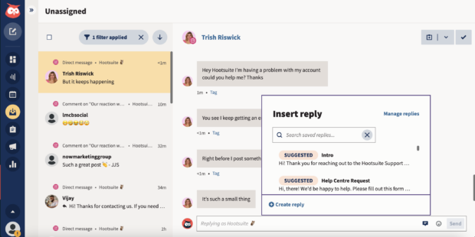](https://blog.hootsuite.com/wp-content/uploads/2024/01/Social-Media-Automation-7.png)

**2. Meta Business Suite**

If you primarily use Meta platforms, Meta Business Suite provides some great tools to help you automate your social media posts, Stories, ads, and analytics.

Just a note: You can create and schedule posts in the Business Suite, but only for your Meta accounts. If you’re a content creator or marketer on LinkedIn, Pinterest, YouTube, or Twitter, you may want to use third-party social media automation software.

Meta Business Suite is a good tool for smaller teams who are only on Instagram and Facebook. If you’re a larger team with needs like content approval workflows, then you should consider

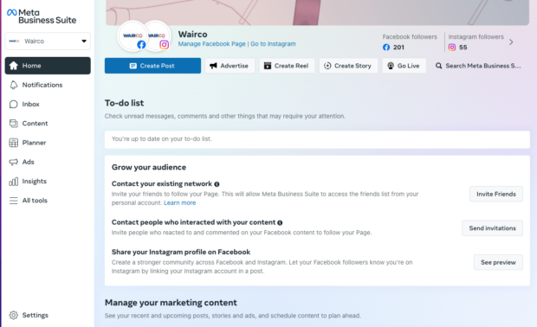

**Key features**

* Scheduling. Scheduling capabilities for Facebook and Instagram
* Reporting. Analytics for Facebook and Instagram
* Media. Free music library

**3. Brandwatch**

This tool helps automate social listening by analyzing social conversations in real-time. It provides alerts of spikes in social conversation or sentiment. This automatically informs you of potential crises or viral hits before they happen.

As far as automation tools for social media go, Brandwatch is like your resident watchdog. You set up a few different listening streams, then watch it work for you.

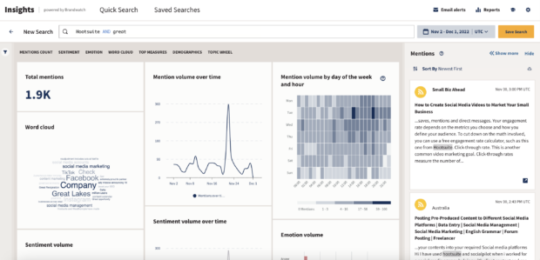

**Email marketing terms.**

Email Marketing Tools

Email marketing tools are tools marketers use to create, send, test, optimize, and report on their email campaigns. One of the most common email marketing tools is an email service provider, or ESP, like Campaign Monitor. Campaign Monitor enables businesses to craft beautiful emails, create automated journeys, and deliver personalized messages that improve your relationship with customers.

ESPs often integrate with key technologies your business needs. For instance, Campaign Monitor’s Salesforce integration enables you to automatically pull in key data that will power automated, personalized email campaigns. This means you can deliver exactly the right message at the right time to the specific subscriber, building better relationships. These integrations and built-in features are examples of tools within a tool.

When choosing an ESP, or any type of email marketing software tool, you want to make sure that the features offered are appropriate for your business goals. Too often, brands end up spending too much money on a tool with features they don’t even use. Likewise, saving money by choosing an ESP that doesn’t offer all the features you need. Without the right features, you’re leaving money on the table. That’s why Campaign Monitor offers several types of pricing plans so you can choose between Pay As You Go and a more robust plan.

But an ESP isn’t the only type of email marketing tool. An email marketing tool could be a specific tool related to email marketing like an email subject line generator, or an inbox placement testing tool, or a suite of tools that enables a marketer to do all their email marketing end-to-end.

**Features of Email Marketing**

There are various features of email marketing:

1. HTML, Responsive Layout
2. Easy Integration
3. Deliverability Help
4. Dedicated IP Address
5. CAN-SPAM Compliance Built-in
6. Advanced List Maintenance
7. Message Automation

**Benefits of Email Marketing**

The following are the benefits of email marketing:

1. Increase leads
2. Gathering feedback and survey
3. Sending timely campaigns
4. Creating personalized content
5. Improving sales
6. Communicating with your audience
7. Providing cost-effective campaigns
8. Having a forum for self-promotion
9. Generating traffic to your site

**Drawbacks of Email Marketing**

The following are the drawbacks of email marketing:

1. Keeping customers engaged
2. Being branded as a spammer
3. Delivery issues
4. Breaking the law
5. Design issues

**Email Marketing Tools**

Email marketing tools are the tool which the marketers use to make, send, test, upgrade, and report on their email campaigns. One of the most widely recognized email marketing tools is an email service provider such as a campaign monitor. Campaign Monitor empowers organizations to make wonderful emails, make automated journeys, and deliver customized messages which improve their relationship with clients.

Email marketing tool is defined as a software and application which we use in email campaigns. We use email marketing tools for:

* Optimizing email
* Generating email reports
* Sending email
* Measuring email metrics
* Email design
* Email building

**Types of Email Marketing Tools**

There are many types of email marketing tools:

1. HubSpot email marketing
2. Sender
3. MailerLite
4. Moosend
5. Mailjet
6. Mailchimp
7. Omnisend
8. Litmus
9. Drip
10. Mad Mimi
11. Constant Contact
12. Cake Mail
13. Flashissue
14. Zoho
15. AWeber
16. iContact
17. GetResponse
18. LeadPages
19. BenchMark
20. Crystal
21. Voila Norbert

**1. HubSpot Email Marketing**

HubSpot is an email marketing tool which is popular for its marketing automation platform. It has recently launched a free email marketing tool, which can meet the 'transactional email' needs of a small business.

Even if you need to send payoff messages from lead offers, thanks to emails after purchase, or simply promote current campaigns, Hubspot can do a free version of email marketing. Probably the best part of Hubspot's free email tool is its utility. The HubSpot tool has an easy drag-and-drop visual editor and also equips you with templates designed to get you up and running instantly.

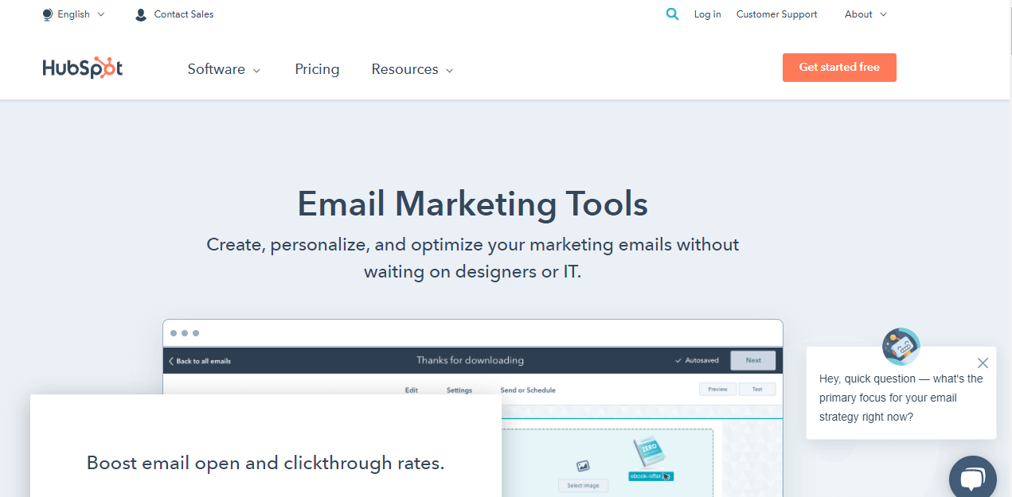

**2. Sender**

Compared to other free email marketing tool in the market, the sender stands out with features that ensure deliverability. It allows you to make fabulous newsletters without any knowledge of HTML. Simply from the template, select it and then customize it with components such as text, pictures, and recordings. You can also customize your newsletters for each beneficiary to make a more significant impact.

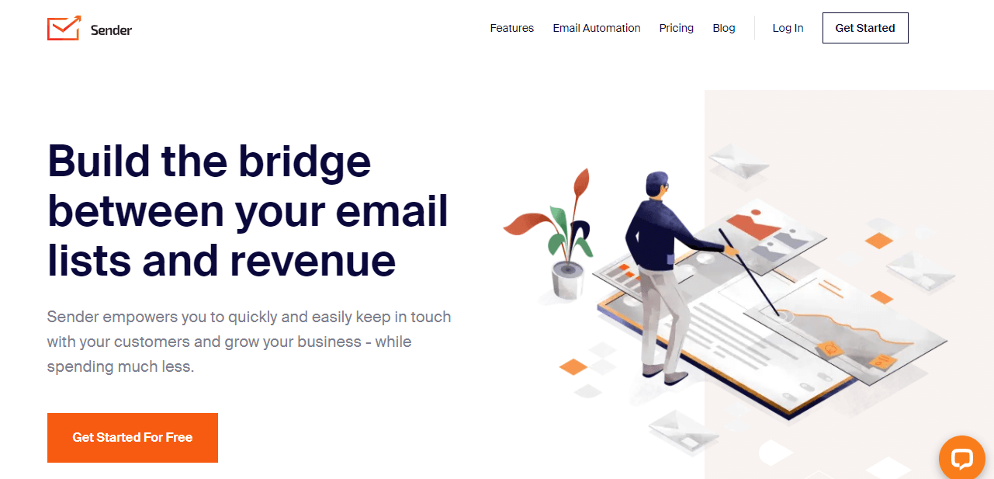

**3. MailerLite**

Complex features such as landing page builder and the pop-up customizer make MailerLite stand apart among free email tools in the market. Aside from the essentials, such as drag-and-drop email builder, the tools also include a fantastic text editor and a built-in photo editor in order to make splendid emails.

We can make reactive landing pages so that we can match the emails that you send, which will progress our chances of driving changes. We can run split tests on various email varieties to perceive what works best to drive clicks and transformations. MailerLite also furnishes you with an exhaustive campaign report which comprises significant details like open rate, unsubscribe rate, and click rate.

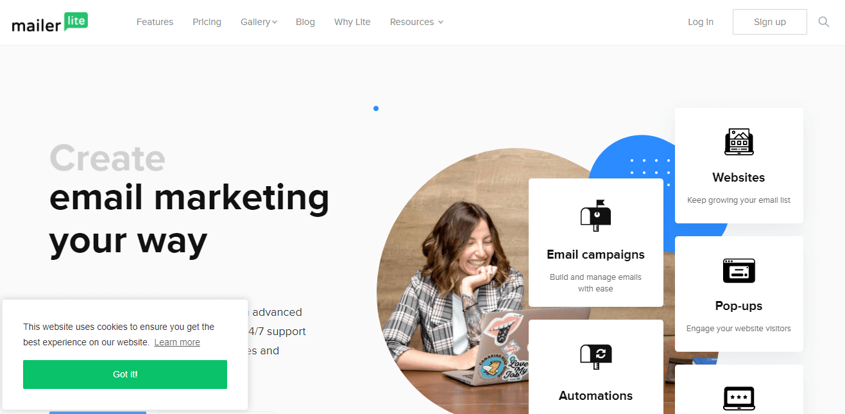

**4. Moosend**

Moosend is another tool that we use for email marketing which allows you to robotize tedious tasks and saves your time. You can also design social email campaigns on the basis of your subscribers' data as well as exercises. You can utilize its advanced segmentation feature to send profoundly precise emails to every beneficiary, expanding the open rate and click-through rate.

Moosend gives you a point-by-point performance report of crusades, so you know precisely how to streamline your crusade and improve results. You can even coordinate it with a portion of your most loved applications to consistently pass on vital information between various tools. Moosend is the only free email marketing tool which won't contain its logo in your emails.

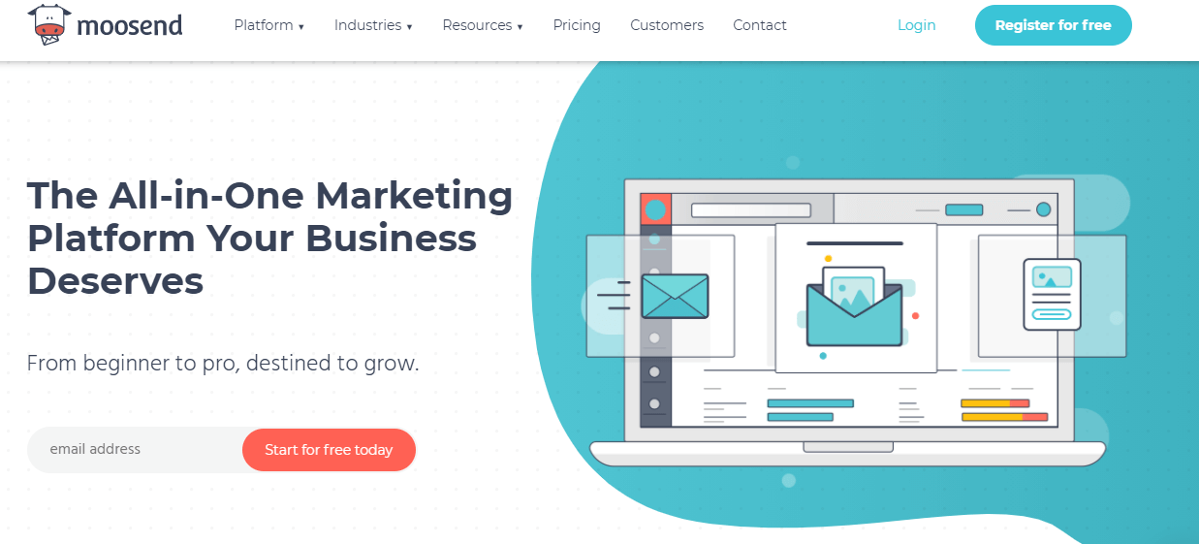

**5. Mailjet**

This email marketing software includes intuitive and cooperative tools to support you build powerful email marketing campaigns. You can tailor any of the pre-designed templates and make responsive emails to influence any beneficiary, no matter what computer they are using. If you are working in a team, then you like the platform's real-time collaboration feature that considers consistent, coordinated effort.

Using this tool, you can also include dynamic content so that you can make customized and important emails for every beneficiary. This encourages you to improve the effectiveness of your email marketing campaigns. You can also integrate the platform with your CRM and handle your entire mailing list from a single dashboard.

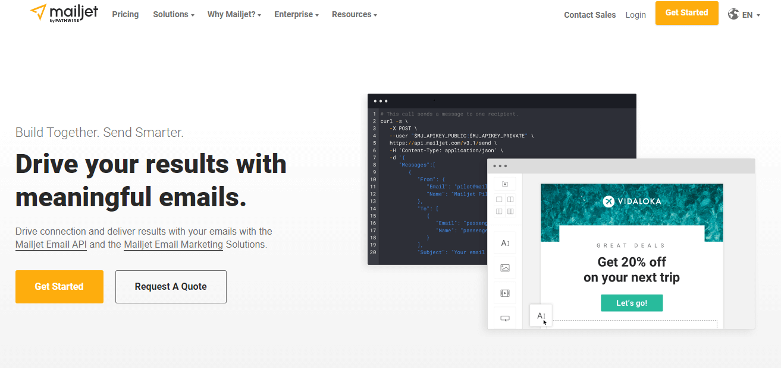

**6. Mailchimp**

Mailchimp is an innovator in email marketing tools which you've likely known about. Their free plan offers you fundamental email marketing features, for example, email creation and scheduling. What makes this an extraordinary email marketing tool is its stunning recommendations feature, which gives you important crowd experiences to streamline your marketing endeavors.

The content manager makes it easier to design emails on the platform by allowing you to save your pictures and files for easy access. With the help of Mailchimp, you can automate your emails at vital steps of the purchaser venture, so you can undoubtedly convey welcome emails, abandoned cart reminders, and order confirmations.

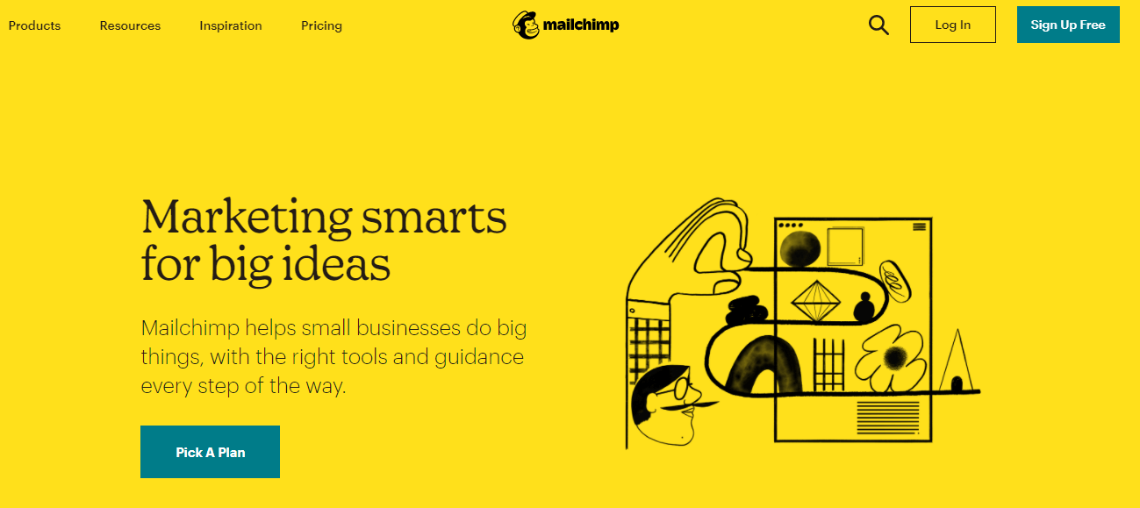

**7. Omnisend**

Omnisend is another interesting tool for email marketing that integrates all your communication platforms in a single place. Omnisend's free plan contains the only email; however, it's all that anyone could need to support the email marketing efforts of small as well as medium businesses. It permits you to automate your email delivery utilizing conduct triggers and effectively time your communications depending on your accommodation.

You can use its complete crowd bits of knowledge to convey more applicable email marketing messages. Design an interesting newsletter utilizing time-saving features like the Product Picker, which allows you to choose all the items you need to remember for your email. You can also comprise scratch cards, discount coupon codes, and blessing boxes to additionally upgrade your email execution.

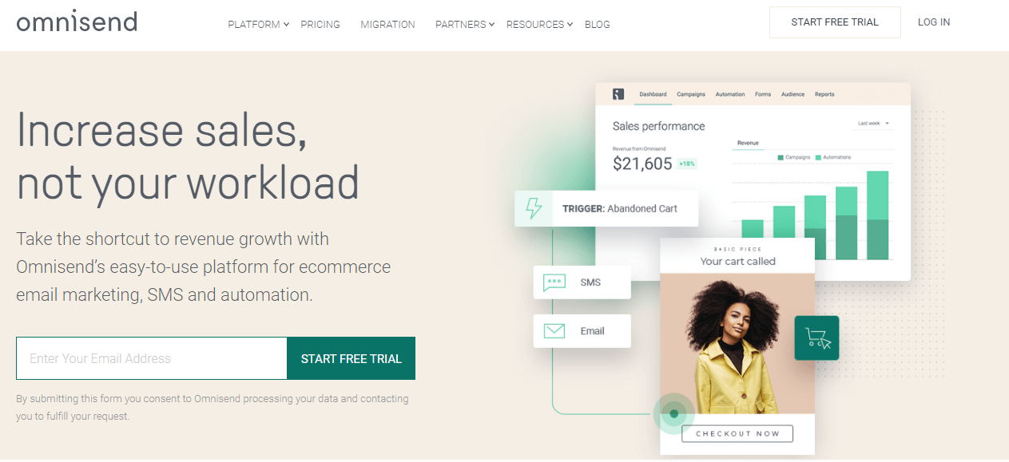

**8. Litmus**

Litmus is a highly adaptable email testing and tracking tool. Using this tool, you can test your message in both conventional web browsers and popular mobile phones such as Windows, Android, and Apple.

We can use Litmus for the purpose of render testing and ensure your innovation is upgraded for some random device. You are able to test more than 40 customers and devices, and Litmus can generate a test email to a place that you can send to your ESP with a single click. In less than a minute; you will see a list of desired browsers, ISPs, and devices.

To do this, Target Hero needs account verification, you'll need to sign up and then follow the process of SMS authentication

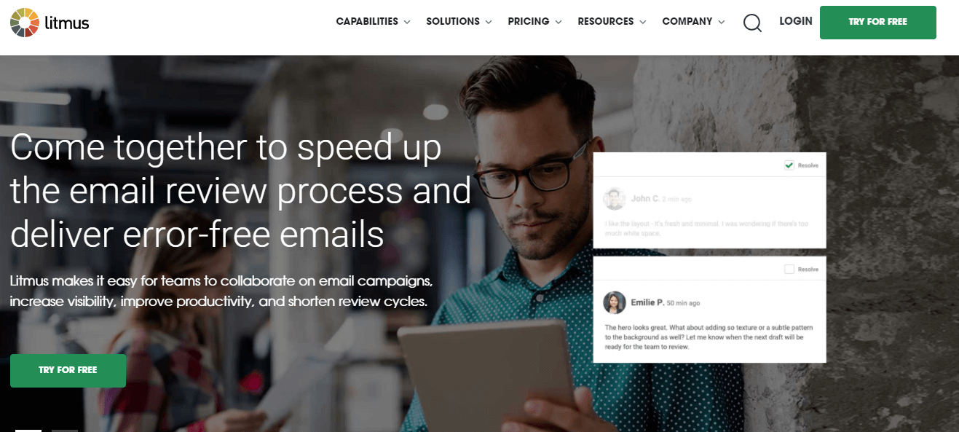

**9.Drip**

Dribble is a versatile email marketing platform that comes with various helpful features containing integration with e-commerce platforms with comprehensive data analytics, Shopify, and message personalization.

For building emails, Drip supports two different tools, which are visual and text-based. This makes effective picture-driven marketing, close to subsequent messages that are more focused and personal to each client.

Altering content is straightforward so that emails will constantly feel pertinent to those who receive them. There's even a custom change tracking feature that gives the organization control over email marketing campaign's success and effectiveness.

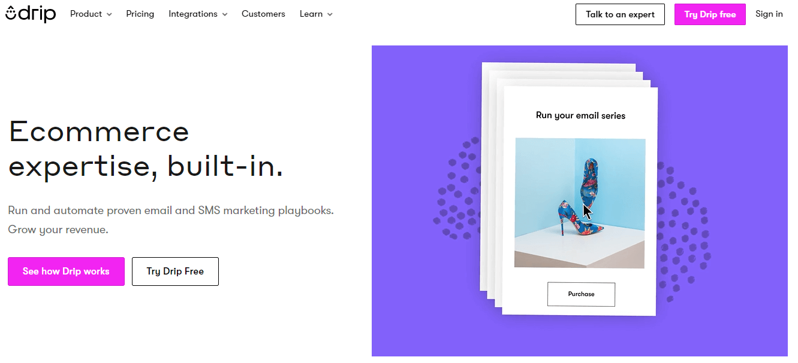

**10. Mad Mimi**

Mad Mimi is another essential tool for email marketing. By using this tool, we can make professional-grade emails along with straightforward WYSIWG editor of Mad Mimi. Select from 39 networking buttons such as like, share, retweet and pin, and customize your emails to add links easily.

Besides making new email marketing campaigns, we are able to copy campaigns by utilizing the clone tool to modify the original document without making changes to earlier forms of our work.

There is no need for the clumsy among us to be concerned about accidentally deleting our email campaigns since we can usually undo it.

With the help of detailed reporting features, we can see the number of messages or emails that were opened, a number of embedded links, the number of shares there were via online media and much more. We are also able to find out the information about the links that any specific user clicks on.

Mad Mimi coordinates with Google Analytics to give top to bottom insights and click tracking. Get "forward to companion" reports, and export them to Excel if you want. View ongoing reactions on your social media activity with respect to email crusades.

**11. Constant Contact**

Look through various design layouts or specifically craft your own. Addition a comprehensive arrangement of additional features if you want, such as images, polls, documents, videos, and links to the surveys.

Text and pictures can likewise be imported straightforwardly into the WYSIWYG editor. Make exhaustive reports on your email missions in order to display a number of opt-outs complaints, forwards, bounces and click-throughs. The social media buttons and social-share toolbars such as Facebook, Twitter, and LinkedIn - will do something amazing to support traffic to your site page.

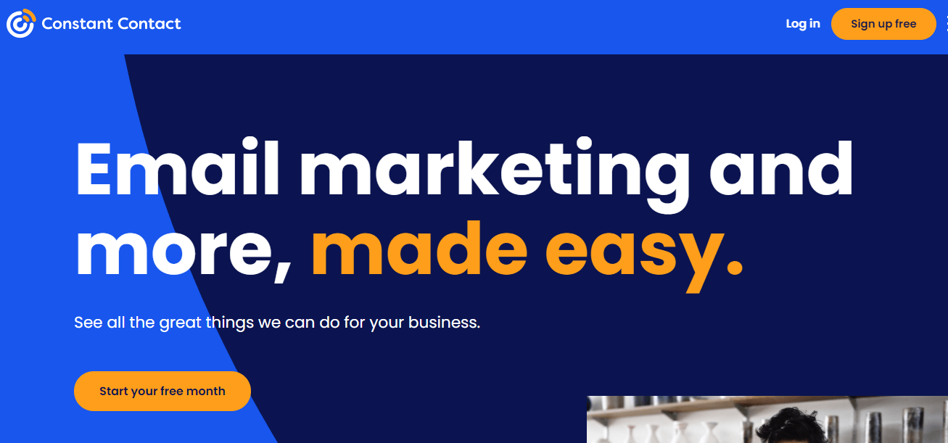

**12. CakeMail**

CakeMail is another interesting tool for email marketing. One of the outstanding functionalities is Split A/B testing, which can be used to determine the best mailing list or Spam Assassin, ensuring that your message does not end up in spam. The Google Integration of the CakeMail tool allows you to see point-by-point details about how each campaign is proceeding.

Email sending is a consistent cycle. Simply provide the title to your campaign, design your email, set your recipients, and pick an opportunity to send. Choose from twenty default layouts with completely adjustable alternatives and upload your own. HTML-smart clients will be satisfied with the high-level altering alternative. The editor likewise allows you to add, delete, and adjust your email areas such as online media components, pictures, Google Maps, QR codes, pictures, and social media elements.

**13. Flashissue**

Flashissue is probably a great tool for emailing newsletters. A straightforward interface is the one that consolidates email marketing with content curation. Sign in via Facebook or Google and have newsletters emailed to your contacts within five minutes.

Regardless of what your newsletter's primary concern is, you can pull the content from blog posts or search the web to find content from various sources-As a result, Flashissue summarizes this content for you. When you are populating the editor with several story outlines, then you are able to modify the description of the headline and articles so that you can customize it for the readers. This permits a more custom-fitted emailer instead of simply conventional news.

After this, you have to upload the banner and choose the ideal method of conveying it. However, the free version boasts plenty of functionality- through Flashissue, you can send the newsletter, or you can use various platforms to send your newsletters such as Google+, LinkedIn, Facebook, and Twitter.

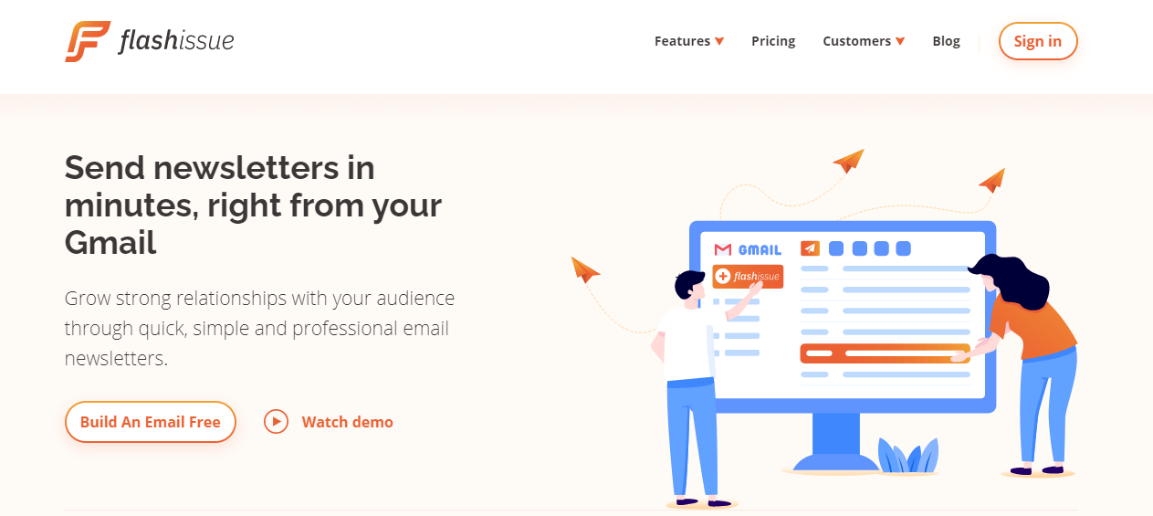

**14. Zoho**

The campaign process of Zoho is separated into three areas: Basic Details, where you can choose the name of the campaign and the details of the email, the Audience, and Content. The Last is self-explanatory.

When you select your beneficiaries and other details of the campaign, then you can complete your campaign.